**BIBD Mini Project**

**Installing MongoDB and Setup MongoDB:**

1. Run the setup file and click on **Next**.

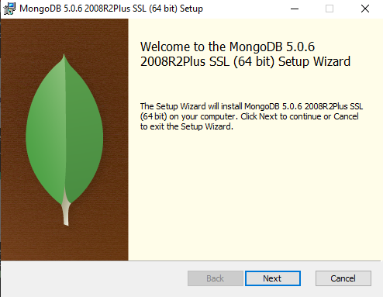

1. **Accept the terms in the License Agreement** and then click on **Next**.

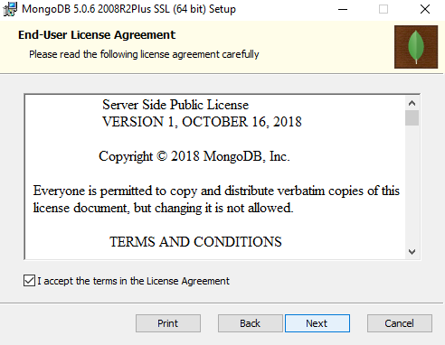

1. Click on **Complete** setup type.

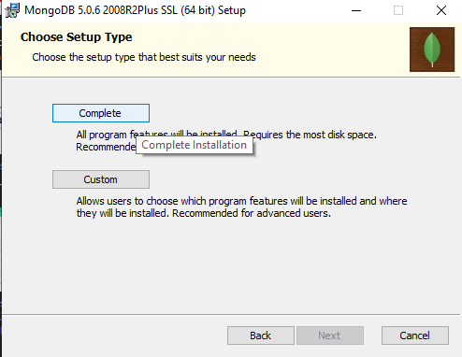

1. Don’t change any settings in Service Configuration just click on **Next**.

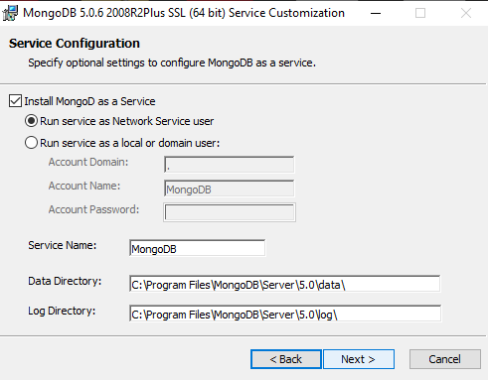

1. If you want MongoDB Compass let the check box be selected and click on **Next** or else uncheck the check box and then click on **Next**.

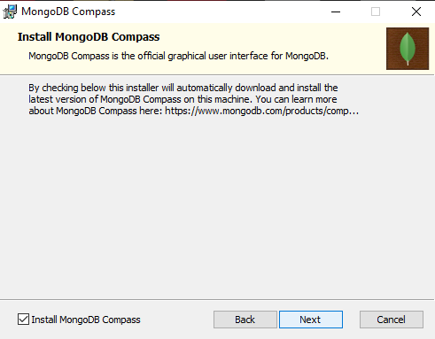

1. Click on **Install** to install MongoDB on your system.

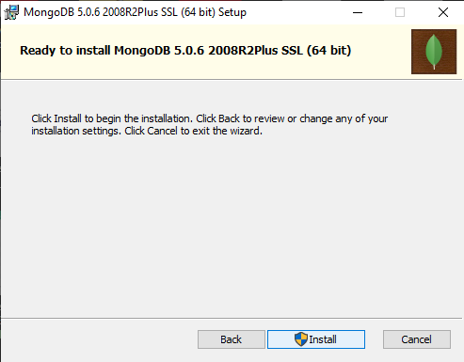

1. After installation is finished, click on **Finish** to exit the Setup of MonogDB.

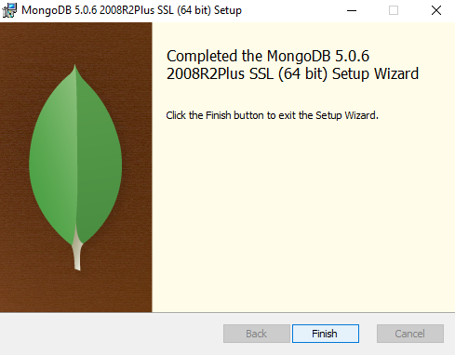

1. Now go to File Explorer, and go to Local Disk C and create a new folder “data”.

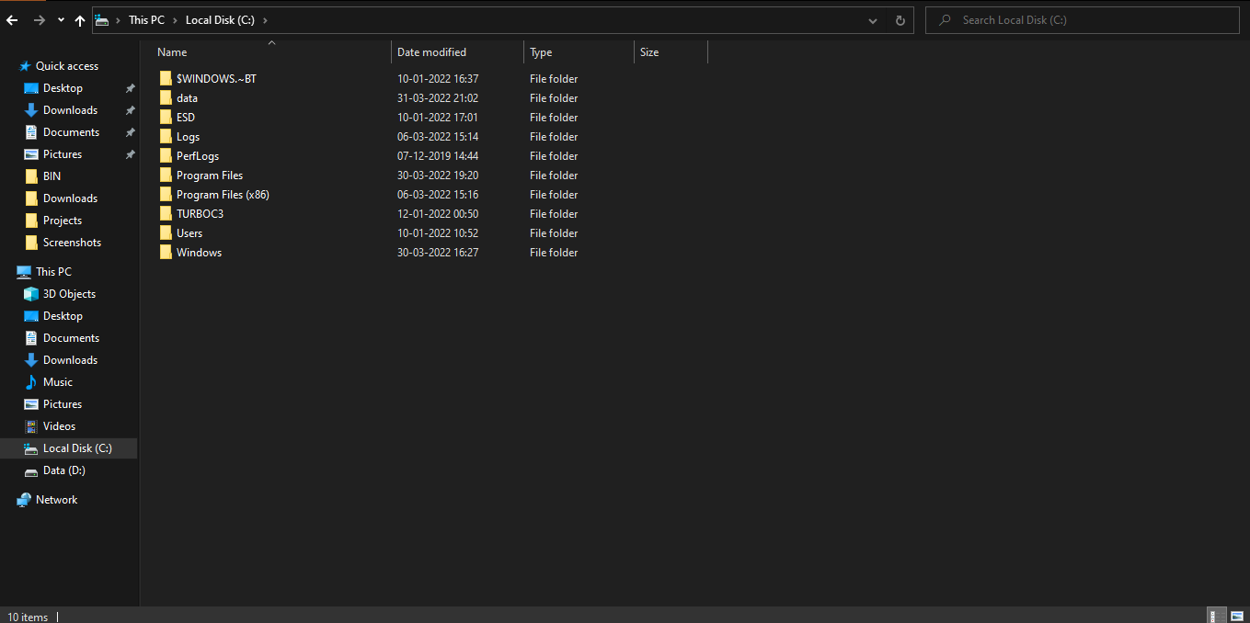

1. Now create a new folder “db” inside data folder.

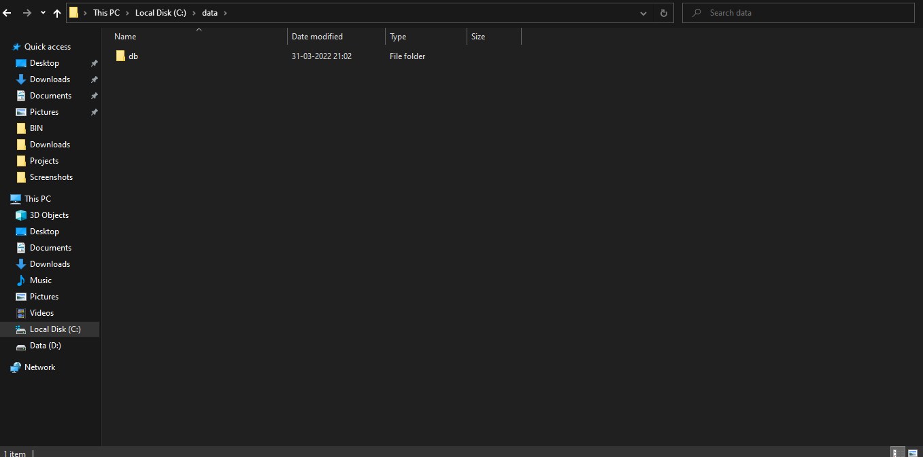

**Code:**

SERVER:

cd C:\Program Files\MongoDB\Server\5.0\bin

mongod

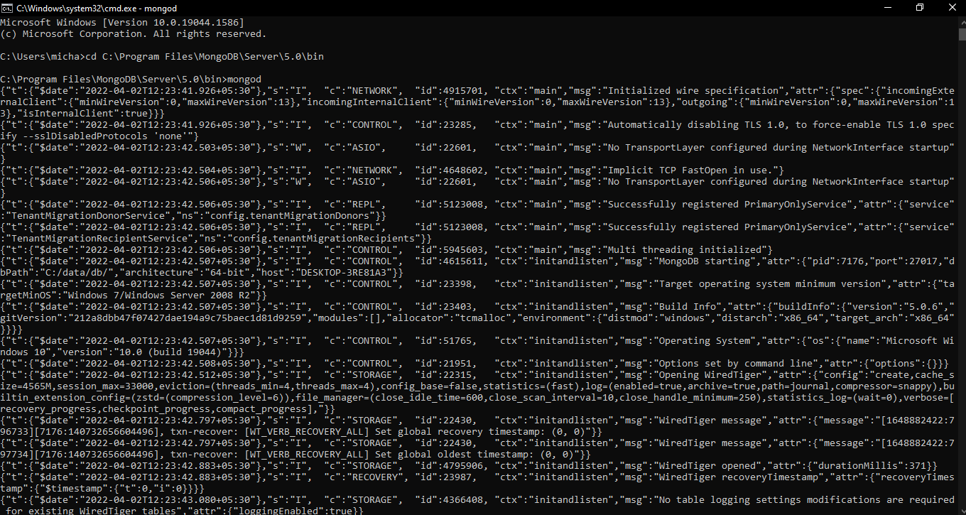

CLIENT:

cd C:\Program Files\MongoDB\Server\5.0\bin

mongo

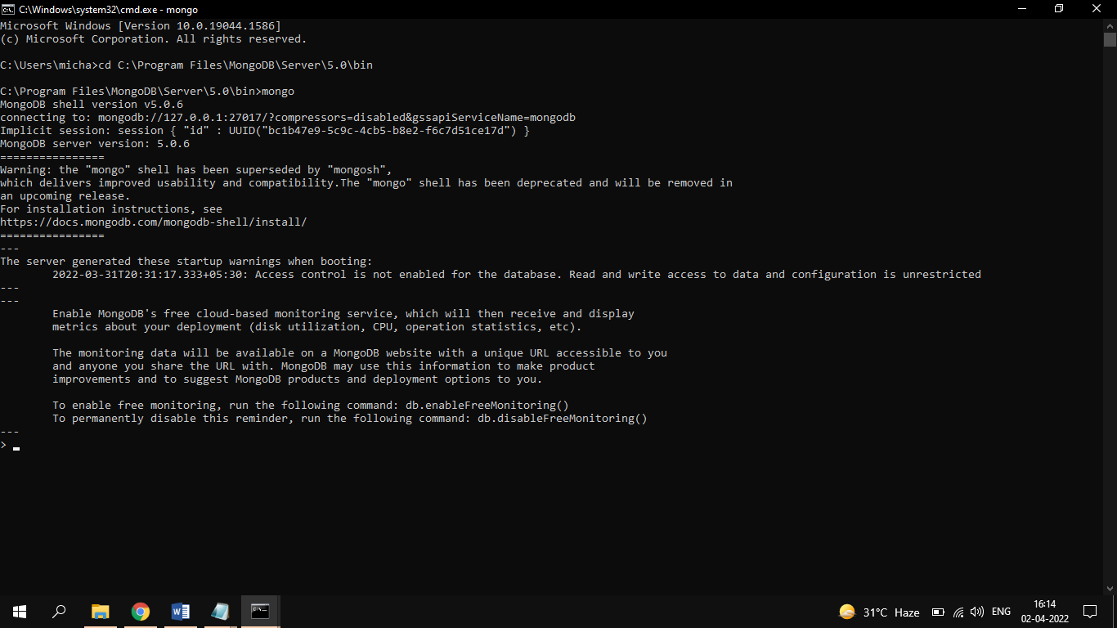

show dbs

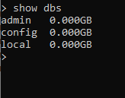

use Mobiles

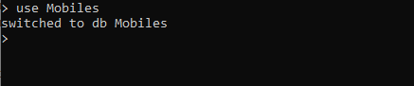

db.mobdetails.insertOne({srno: 01, name: "OnePlus", price: 50000, type: "Phone"})

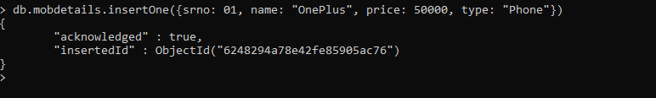

db.mobsdetails.find().pretty()

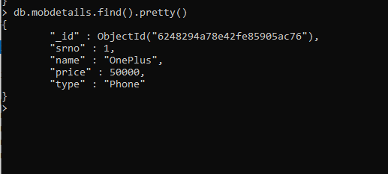

db.mobdetails.insertMany([

{srno: 02, name: "Apple", price: 75000, type: "Phone"},

{srno: 03,name: "Redmi", price: 15000, type: "Tab"},

{srno: 04,name: "Vivo", price: 25000, type: "Phone"},

{srno: 05,name: "Oppo", price: 10000, type: "Tab"},

{srno: 06,name: "Xiaomi", price: 30000, type: "Phone"},

{srno: 07,name: "Realme", price: 20000, type: "Tab"}

])

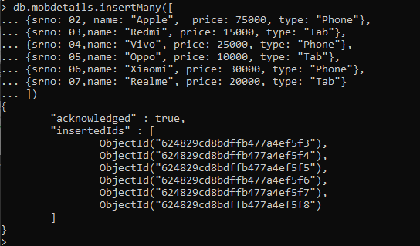

db.mobdetails.find().pretty()

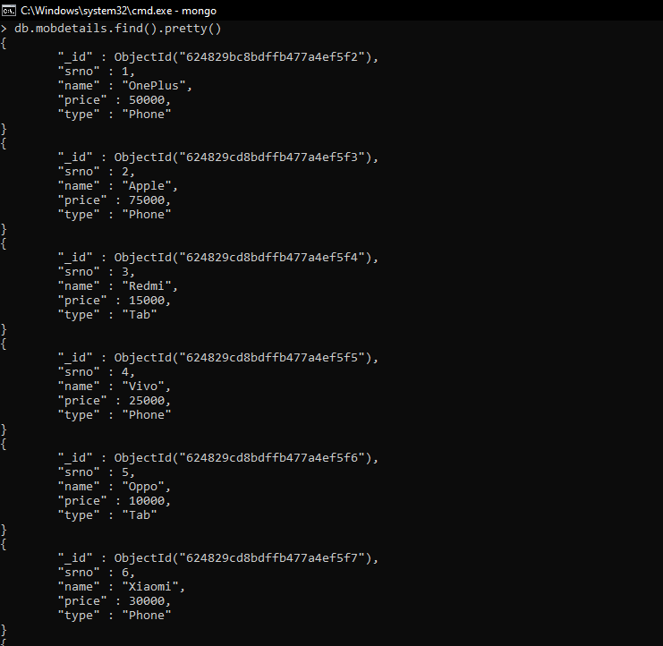

db.mobdetails.updateOne({name: "Apple"}, {$set:{price: 100000}})

db.mobdetails.find().pretty()

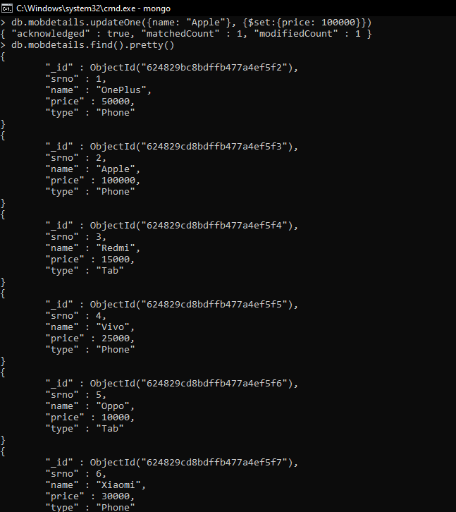

db.mobdetails.updateMany({type:"Phone"}, {$set: {price: 50000}})

db.mobdetails.find().pretty()

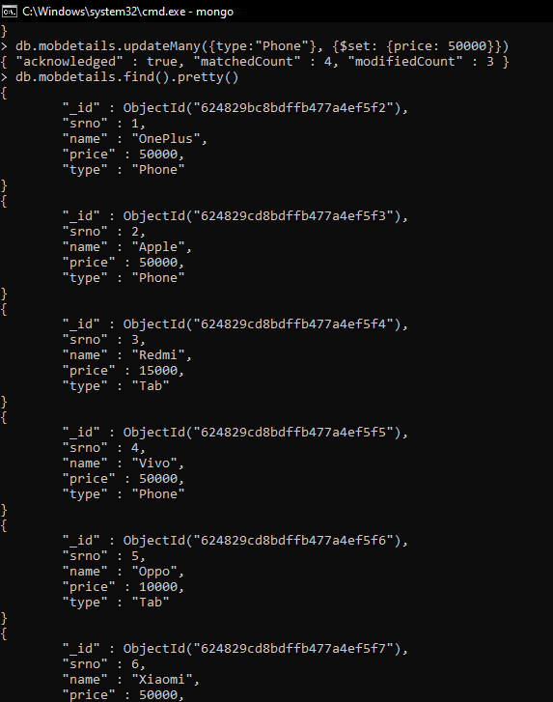

db.mobdetails.replaceOne({name: "Oppo"}, {name: "Micromax"})

db.mobdetails.find().pretty()

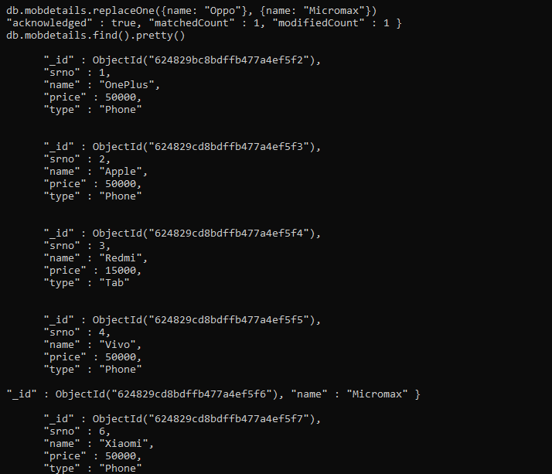

db.mobdetails.deleteOne({"price":50000})

db.mobdetails.find().pretty()

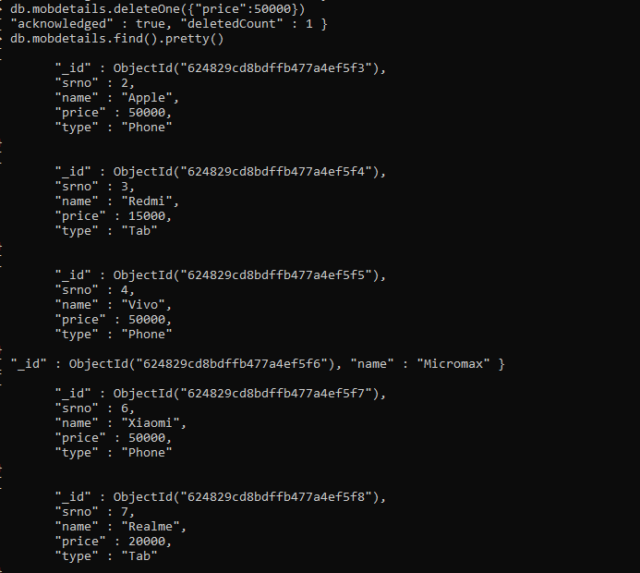

db.mobdetails.deleteMany({type:"Phone"})

db.mobdetails.find().pretty()

